JAMES ISLAND YACHT CLUB OPEN REGATTA
June 15-16, 2019
James Island Yacht Club

Charleston, SC

Sailing Instructions
A Main and Outer Courses
B Junior Course

A

SAILING INSTRUCTIONS – MAIN and OUTER COURSES
(Updated June 3, 2019)

- RULES - This regatta will be governed by current version of The Racing Rules of Sailing (RRS), the prescriptions of the United States Sailing Association and the NOR for the 2019 SAYRA JR. Grand Prix.

- ELIGIBILITY The regatta is open to yachts of all classes. Classes with four or more boats entered may compete as a class. Sea Island One Design and all Junior classes need only three boats entered.

- NOTICES TO COMPETITORS - Notices to competitors will be posted on the official notice board(s) located at the glass doors of the club’s meeting room.

- CHANGES IN THE SAILING INSTRUCTIONS: Any change to the sailing instructions will be posted on Saturday at the conclusion of the skippers meeting, and on Sunday by 1000 hours. Changes to the SIs on the water will be made before the Warning signal. The L flag will be raised and the change will be made using radio and loud hauler to affected classes.

- SIGNALS MADE ASHORE
  - Signals made ashore will be displayed from the club’s flagpole.
  - When code flag "AP" is displayed ashore, “1 minute” is replaced with “not less than 30 minutes” in the RRS Race Signal “AP.”

- SCHEDULE OF RACES
  - Races are scheduled as follows:

Saturday, June 15 1100 Skipper Meeting
1255 First Warning
Other races to follow

Sunday, June 16 1155 First Warning
Other races to follow
  - No races will be started after 1500 on Sunday, June 16
  - The number of races to be sailed will be as many as possible.

- CLASS FLAGS
  - Class flags will be announced at the Skipper’s Meeting and posted on the Official Notice Board.

- RACING AREA
  - Attachment ( A ) shows the location of racing areas.

- COURSES
  - The diagrams in Attachment ( B ) show the courses, including the approximate angles between legs, the order in which marks are to be passed, and the side on which each mark is to be passed.
  - No later than the warning signal, the RC signal boat will display the course to be sailed.

- AREAS THAT ARE OBSTRUCTIONS
The following areas are designated as obstructions: “middle ground”.

- MARKS
 | Main Course |  | Outer Course
Marks W, G, L | Yellow Sphere |  | Orange Cylinder
Starting Mark | White Sphere |  | White Sphere
Finish Mark | Orange Sphere or pin boat |  | Orange Sphere or pin boat
Change Mark | Orange Sphere |  | Yellow Tetrahedral
- THE START
  - Races will be started using RRS 26.
  - The starting line will be between the staff displaying an orange flag on the RC signal boat on the starboard end of the starting line and the port end starting mark.
  - A boat starting later than 5 minutes after her starting signal will be scored Did Not Start without a hearing. This is in addition to rules A4 and A5.

- THE FINISH
  - The finishing line for courses 1, 2, 3, and 4 will be between a staff displaying a blue flag on the finishing boat at the starboard end and the port end finishing mark or pin boat displaying an orange flag

- PENALTY SYSTEM
14.1 Rule 44.1 is changed so that the Two-Turn Penalty is replaced by the One-Turn Penalty (including one tack and one gybe) for the SIOD Class, Hobie Classes and the Wasp Class.
14.2 Appendix V1 will apply to all classes except for the SIOD class, Hobie Classes and the Wasp class.
14.3 Appendix V2 will apply for all Classes.
14.4 Any boat that does a two-turns or one-turn penalty will report this fact to the race committee as soon as possible after finishing, giving them the sail number of the boat doing the penalty turns. Only the RC may protest a boat if this rule is broken.

- TIME LIMITS
  - The time limit for the first boat of each class to pass the first mark will be 30 minutes.
  - The time limit for the first boat in each class to finish is 1 hours.
  - Boats failing to finish within 30 minutes after the first boat sails the course and finishes will be scored Time Limit Expired, TLE. This is an addition to RRS 35 and A4.1.

- PROTESTS AND REQUESTS FOR REDRESS
  - Protest forms are available at the race office. Protests shall be delivered there within the protest time limit, which starts when the Committee Boat reaches the dock and ends 30 minutes later. The same protest time limit applies to all protests by the RC and jury and to requests for redress. This modifies RRS 61.3 and 62.2.
  - Notices of scheduled protest or requests for redress hearings will be posted within 30 minutes of the protest time limit to inform competitors of hearings in which they are parties or may be parties affected by a request for redress. This will constitute notice to all parties under RRS 63.2 and its Prescription.
  - Hearings will be held in the jury room, located at the meeting room

17.0 SCORING
  - Low point scoring system will be used as describe in Appendix A except that one score will be excluded after five races have been sailed. This is in addition to RRS A2
  - One (1) race is required to be completed to constitute a series.
  - Boats scored TLE will receive 2 points more than the number of boats that finished.

18.0 SAFETY
  - US Coast Guard approved floatation device must be carried for each person, on each boat from the time the boat leaves the shore until the time the boat returns to the shore.
  - A boat that retires from a race shall notify the race committee as soon as possible.
  - A boat and its crew shall at all times keep clear of all commercial vessels and shall not maneuver in any manner which would cause a commercial vessel to be unable to sail their proper course or carry out their commercial functions in a normal manner.
  - A boat whose actions or maneuvers result in a Danger Signal (5 Horns or Sounds) from a commercial vessel may be protested.
  - Only the RC or PC may protest a boat under this Sailing Instruction. This is in addition to RRS 60.1.

- SUPPORT BOATS
Team leaders, coaches and other support personnel shall stay outside areas where boats are racing from the time of the preparatory signal for the first class to start until all boats have finished or the race committee signals a postponement, general recall or abandonment.

- RADIO COMMUNICATION
A boat shall neither make radio transmissions while racing, except for emergencies, nor receive radio communications not available to all boats. This restriction also applies to mobile telephones.

- PRIZES
Prizes will be given as follows:
The number of trophies will be determined by the number of boats entered in each class as follows:
1st 4 to 6 registered ( except SIOD )
1st, 2nd 7 to 9 registered
1st, 2nd, 3rd 10 to 14 registered
1st, 2nd, 3rd, 4th 15 to 19 registered
1st, 2nd, 3rd, 4th, 5th 20 or more registered

- The A.C. Hollings Perpetual Trophy will be engraved with the name of the first place winner of the class with the largest number of registered yacht. The winner will receive an appropriate trophy for his / her retention.
- The Clyde Easterling Perpetual Trophy will be engraved with the name of the SIOD first place winner. The winner will receive an appropriate trophy for his / her retention.
- JIYC will award a special trophy to the youngest JIYC sailing skipper completing all races scheduled in his / her class.
- JIYC IOBG will award a special trophy to the oldest JIYC sailing skipper completing all races scheduled in his / her class.

- DISCLAIMER OF LIABILITY
Competitors participate in the regatta entirely at their own risk. See rule 4, Decision to Race. The organizing authority will not accept any liability for material damage or personal injury or death sustained in conjunction with or prior to, during, or after the regatta.

23.0 ADDITIONAL INFORMATION:
In junction with the JIYC Open Regatta, the 2019 USSCA NORTH AMERICAN CHAMPIONSHIP will be held at the James Island Yacht Club on June 12 – 16. Online Registration is available on Yacht Scoring (YachtScoring.com).

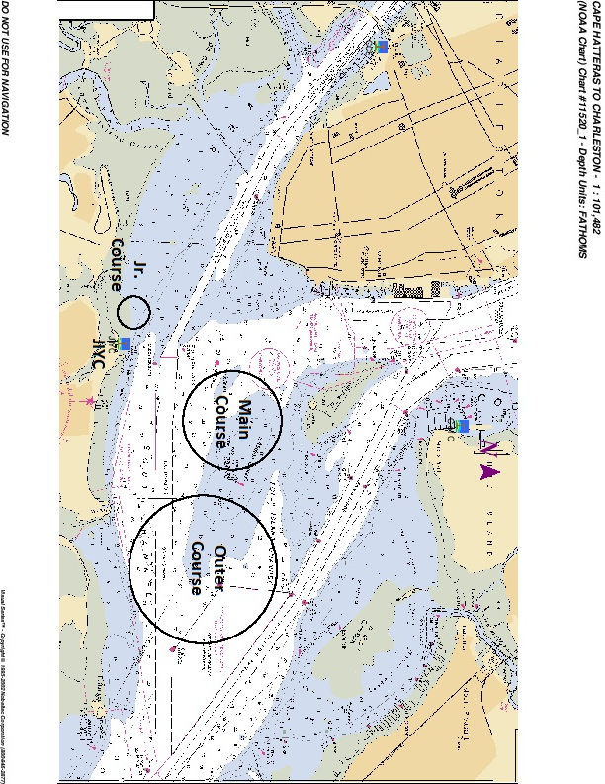
Attachament A

WIND 1. S-W-F
2. S-W-L-W-F
3. S-W-L-W-L-W-F
4. S-W-G-L-W-F
W MARK 5. S-W-L-W-L-W-L-W-F

ALL MARKS TO PORT

G MARK

L MARK

START PIN RC FINISH

Attachment ( B )

B

JAMES ISLAND YACHT CLUB OPEN REGATTA
June 15 - 16, 2019
James Island Yacht Club
Charleston, SC

SAILING INSTRUCTIONS – JUNIOR COURSE
(Posted May 29, 2019)

- RULES - The regatta will be governed by The Racing Rules of Sailing (RRS) and the NOR for the 2019 SAYRA JR. Grand Prix.

- NOTICES TO COMPETITORS - Notices to competitors will be posted on the official notice board(s) located at the glass doors of the club’s meeting room.

- CHANGES IN THE SAILING INSTRUCTIONS: Any change to the sailing instructions will be posted on Saturday at the conclusion of the skippers meeting, and on Sunday by 1000 hours.
Oral changes to the Sailing Instructions may be given on the water by hail from the Signal Boat under code flag “L” in accordance with RRS 90.2 (c). Changes must be made before the warning signal.

- SIGNALS MADE ASHORE

  - Signals made ashore will be displayed from the club’s flagpole.
  - When code flag "AP" is displayed ashore, “1 minute” is replaced with “not less than 30 minutes” in the RRS Race Signal “AP.”

- SCHEDULE OF RACES
  - Races are scheduled as follows:

Saturday, June 15 1100 Skipper Meeting
1230 First Warning
Other races to follow

Sunday, June 16 1155 First Warning
Other races to follow
  - No races will be started after 1430 on Sunday, June 16.
  - The number of races to be sailed will be as many as possible.

- CLASS FLAGS
  - Class flags will be announced at the Skipper’s Meeting and posted on the Official Notice Board.

- RACING AREA
  - Attachment ( A ) shows the location of racing areas. The Junior racing area will be area west of the James Island Yacht Club dock. The Green fleet course will be closer to the dock, while the Junior course will be further west.

- COURSES
  - The diagrams in Attachment (B) show the courses, including the approximate angles between legs, the order in which marks are to be passed, and the side on which each mark is to be left. The courses are specified by letter designations.
  - A number following the letter on the course board for courses W and T will indicate the number of times that a course is to be sailed.

- MARKS
Junior Course

Marks 1,2 & 3 | Yellow Tetrahedron
Starting Mark | White Sphere
Finish Mark | White Sphere
Change Mark | Orange Sphere

Green Fleet Course
Marks for the green fleet will be Green Spheres

- THE START
  - Races will be started using Appendix S – Sound-Signal starting system.
  - Junior Fleet and Green Fleet: The starting line will be between the staff displaying an orange flag on the RC signal boat on the starboard end of the starting line and the port end starting mark.
  - Boats whose warning signal has not been made shall keep clear of the starting area and of all boats that are racing. Only the RC may protest a boat if this rule is broken.
  - A boat starting later than 5 minutes after her starting signal will be scored Did Not Start without a hearing. This is in addition to rules A4 and A5.

- THE FINISH
  - Junior Fleet: The finishing line will be between a staff displaying an orange flag on the RC signal boat at the starboard end and the port end finishing mark.
  - Green Fleet: The finishing line will be between a staff displaying an orange flag on the RC signal boat at the port end and the starboard end finishing mark.

PENALTY SYSTEM
The following sections of Appendix V will be in effect: V1 and V2. A boat taking a penalty under V1 or retiring shall notify the Race Committee that they have taken a penalty.

- TIME LIMITS
  - The time limit for the first boat of each class to pass the first mark will be 45 minutes.
  - The time limit for the first boat in each class to finish is 1.5 hours.
  - Boats failing to finish within 30 minutes after the first boat sails the course and finishes will be scored Time Limit Expired, TLE. This is in addition to RRS 35 and A4.1.

- PROTESTS AND REQUESTS FOR REDRESS
  - Protest forms are available at the race office. Protests shall be delivered there within the protest time limit, which starts when the Committee Boat reaches the dock and ends 30 minutes later. The same protest time limit applies to all protests by the RC and jury and to requests for redress. This changes RRS 61.3 and 62.2.
  - Notices of scheduled protest or requests for redress hearings will be posted within 30 minutes of the protest time limit to inform competitors of hearings in which they are parties or may be parties affected by a request for redress. This will constitute notice to all parties under RRS 63.2 and its Prescription.
  - 13.3 A list of boats that have been scored TLE, under instruction 13. 3, or are being protested by the race/protest committee will be posted before the protest time limit. This action by the race/protest committee will serve the requirements of RRS 61.1(c).
  - Hearings will be held in the jury room, located at the meeting room.

- SCORING
  - Low point scoring system will be used as describe in Appendix A except that one score will be excluded after six races have been sailed. This is in addition to RRS A2
  - One (1) race is required to be completed to constitute a series.
  - Boats scored TLE will receive 2 points more than the number of boats that finished.

- SAFETY
  - US Coast Guard approved floatation device must be worn by each person, on each boat from the time the boat leaves the shore until the time the boat returns to the shore.
  - A boat that retires from a race shall notify the race committee as soon as possible.
  - Only the RC or PC may protest a boat for breaking SI Rule 16. This is an addition to RRS 60.1.

18.0 SUPPORT BOATS
Team leaders, coaches and other support personnel shall stay outside areas where boats are racing from the time of the preparatory signal for the first class to start until all boats have finished or the race committee signals a postponement, general recall or abandonment. This rule is waived for the Green fleet Optimist class

19.0 PRIZES
Prizes will be given as follows:
The number of trophies will be determined by the number of boats entered in each class as follows:
1st 3 registered
1st, 2nd 4 to 6 registered
1st, 2nd, 3rd 7 to 9 registered
1st, 2nd, 3rd, 4th 10 to 13 registered
1st, 2nd, 3rd, 4th, 5th 14 or more registered

- The A.C. Hollings Perpetual Trophy will be engraved with the name of the first place winner of the class with the largest number of registered yacht. The winner will receive an appropriate trophy for his / her retention.
- JIYC will award a special trophy to the youngest JIYC sailing skipper completing all races scheduled in his / her class.

20.0 DISCLAIMER OF LIABILITY
Competitors participate in the regatta entirely at their own risk. See rule 4, Decision to Race. The organizing authority will not accept any liability for material damage or personal injury or death sustained in conjunction with or prior to, during, or after the regatta.

Attachament A
